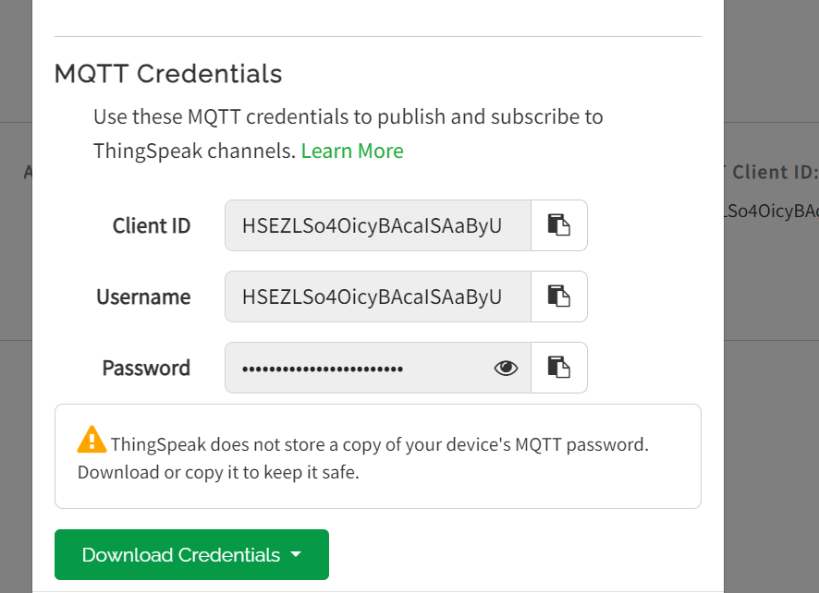

QJjU6Sm2E5Lyk1Kxo3iNiDKV

HSEZLSo4OicyBAcaISAaByU